**INTRODCUTION TO LINUX**

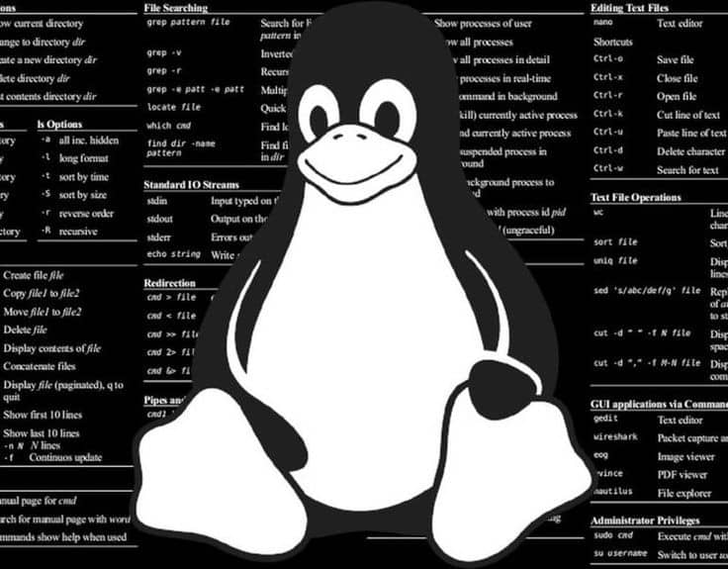

What is Linux: Linux is an open-source operating system, it manages all the hardware resources of a computing device and allocates resources to run processes.

* Developed in 1991
* Allows for multitasking
* Allows for multiple users
* One of the most secure operating systems
* Can be use for any purpose

1.Different Linux distributions

There are over 42 distributions of Linux to name a few,

* Debian
* Kali Linux
* Ubuntu
* Red Hat Enterprise Linux
* CentOS

We will be using Kali Linux for this lab in parallel with Kali Linux Journey.

2.Installing Kali Linux and setting it up

You will need a virtual machine for this.

Step 1:

Go to <https://www.kali.org/>

Step 2:

Click on the download button

Step 3:

Click on “Virtual Machines”

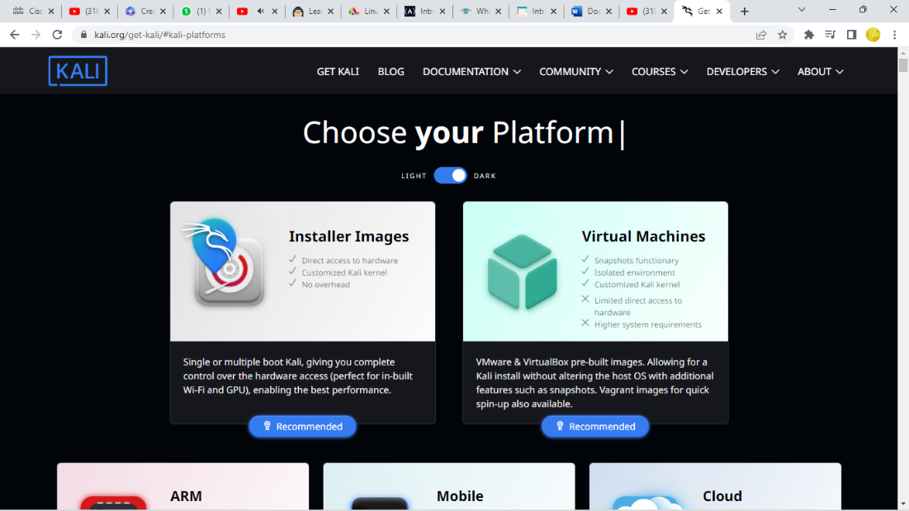

Step 4:

Click on the recommended 64-bit download for the Virtual Machine worksation you have installed already.

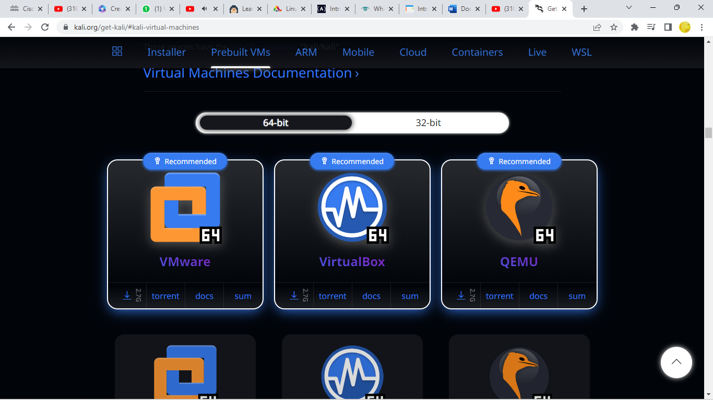

AFTER DOWLOAD:

Step 1:

Open your VM

Step 2:

Click on “File” on your top left corner and select Import appliance.

Step 3:

Click on the yellow file icon and choose your iso image.

Step 4:

Wait for your Kali Linux to finish importing.

After you are done with the installation process begin with the “Command Line” lesson on Linux journey.

Here is the link to Linux journey:

<https://linuxjourney.com/>

Bash line key combinations

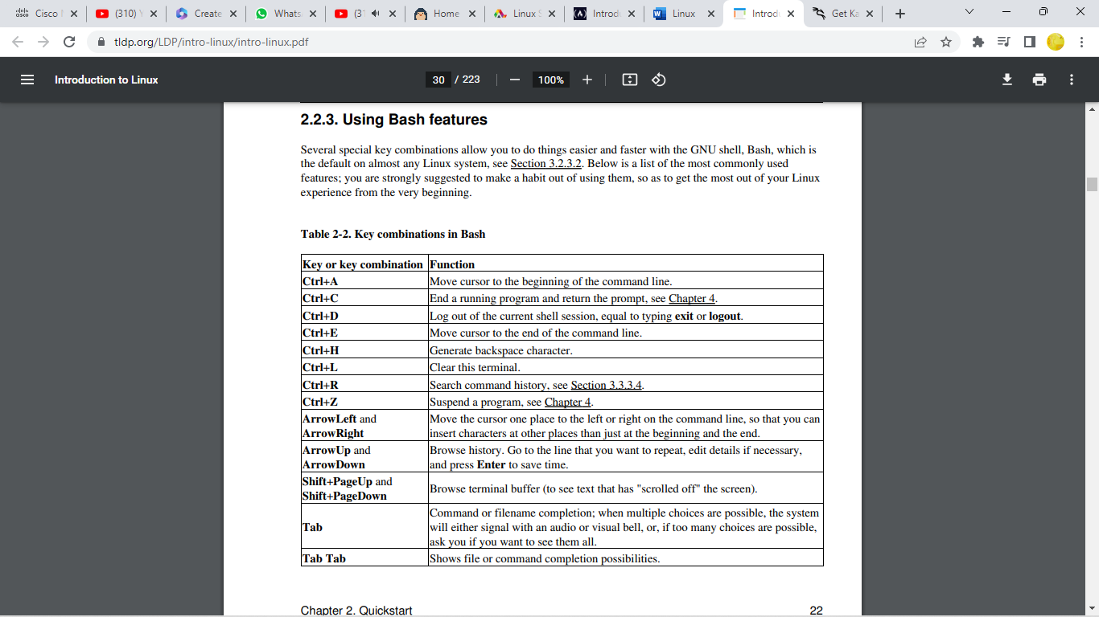

Extra reading:

<https://www.tecmint.com/linux-distro-for-power-users/>

<https://tldp.org/LDP/intro-linux/intro-linux.pdf>

<https://tldp.org/LDP/intro-linux/intro-linux.pdf>

<https://www.techtarget.com/searchdatacenter/definition/Linux-operating-system>